**Abstract**

An often-overlooked function that transportation carriers and operators provide is meal delivery during and after a major disaster. When a hurricane strikes, wildfires consume a region, floods rush in, or an island is nearly devoured by dangerous winds and rains, much of the infrastructure of an area can be wiped out. The food that's available to survivors is either nonexistent or unfit for human consumption.

Although the type of emergency assistance required after a disaster is often fairly easy to identify (for instance, earthquake, flood and hurricane victims almost always need emergency shelter), how it is delivered to the intended beneficiaries can make a huge difference to their level of vulnerability, by allowing them to gain more control of their lives and improving their survival chances. Large-scale emergency response often relies heavily on the channelling of emergency aid from outside the affected area, requiring significant logistics, infrastructure and human resources. Sometimes this can increase vulnerability by stifling local coping mechanisms and undermining local markets.

**Literature Survey-**

1. **Carmen G. Rawls and Mark A. Turnquist(2012)-**Natural disasters often result in large numbers of evacuees being temporarily housed in schools, churches, and other shelters. The sudden influx of people seeking shelter creates demands for emergency supplies, which must be delivered quickly. A dynamic allocation model is constructed to optimize pre-event planning for meeting short-term demands (over approximately the first 72 h) for emergency supplies under uncertainty about what demands will have to be met and where those demands will occur. The model also includes requirements for reliability in the solutions – i.e., the solution must ensure that all demands are met in scenarios comprising of all outcomes. A case study application using shelter locations in North Carolina and a set of hurricane threat scenarios is used to illustrate the model and how it supports an emergency relief strategy.
2. **Balcik Burcu et al(2008)**- Last mile distribution is the final stage of a humanitarian relief chain; it refers to delivery of relief supplies from local distribution centers (LDCs) to beneficiaries affected by disasters. In this study, they considered a vehicle-based last mile distribution system, in which an LDC stores and distributes emergency relief supplies to a number of demand locations. The main decisions are allocating the relief supplies at the LDCs among the demand locations and determining the delivery schedules/routes for each vehicle throughout the planning horizon. They proposed a mixed integer programming model that determines delivery schedules for vehicles and equitably allocates resources, based on supply, vehicle capacity, and delivery time restrictions, with the objectives of minimizing transportation costs and maximizing benefits to aid recipients.
3. **D. Clay Whybark(2007)**- This report is concerned with the inventories that are held for disaster relief and the need for research into their management. Though forecasting is difficult, the evidence is that the number of disasters, natural and political, is increasing. Thus the need for disaster relief is increasing along with the desire to improve the process, including management of disaster relief inventories. Despite decades of enterprise inventory research, little literature is available on disaster relief inventories. In this article the nature of disaster relief, some of the research on disaster relief and on disaster relief inventories is presented. Characteristics of disaster relief inventories important to their management, from acquisition through storage and distribution, are described. As the frequency of disasters increase, the management of disaster relief inventories is an increasingly important area for scientific research.
4. **Berke Philip R et al(2007)**- This study focuses on the human-ecological dimension of disaster resilience after the 2004 tsunami. The paper examines how concepts of social capital and external aid delivery influence community performance in conservation of mangrove ecosystems. Experiences are reported through the words of local informants in six villages in Thailand. Findings indicate that social capital represents a potential for collective action, but design of aid programmes may prevent such action. Programmes that emphasised bottom-up aid delivery mobilised local social capital and directed it toward obtaining resources that fit local needs and capabilities. Alternatively, top-down aid programmes provided significant resources, but oppressed mobilisation of social capital. Implications are that disaster stricken communities should be treated as active participants, rather than the more common perspective that views them as vulnerable and in a state of helplessness.

**Technical Specifications:**

**Length**: A boat’s length is the distance from the tip of the bow to the farthest point on the stern (front to back, measured in a straight line). The length of your boat excludes a swim platform**.(6-7 meters)**

**Beam**: The width of a boat at its widest point**.(2-2.5 metres)**

**Payload**: The boat is having a payload of about **400 kgs.**

**Gunwale**: The top edges of the sides of a boat.(**1.5m**)

**Bow:** The forward or front part of a boat is called the ‘bow’.

**Port:** The left side of a boat when you’re seated and looking forward.

**Stern**: The rear part of a boat is called the ‘stern’.

**Transom**: The ‘transom’ is the stern cross-section of your boat.

Waterline: This is the line (on the hull) at which the boat sits in the water when it’s properly loaded with passengers and equipment.

Draft: ‘Draft’ is the depth of water that your boat needs in order to float freely. The draft is measured as the distance from the waterline to the lowest point of the boat.

Freeboard: ‘Freeboard’ is the distance from the waterline to the lowest point on our boat’s deck.

Cleat: This is a metal fitting to which a rope or line can be secured.

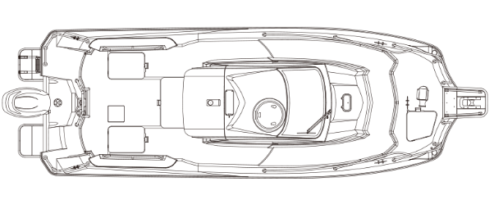

A representation Model:

**Boat Components:**

**Handlebars and throttle:** The operator will use this part for steering the boat by turning the handlebars and applying throttle.

**Safety lanyard (kill switch):** This is a rope or cord that attaches the kill switch to the operator. It will be used as a safety measurement, If anybody fall off the PWC, the lanyard will release and shut down the engine.

**Seat:** This is the area where the operator and passengers will sit.

**Jet intake:** The ‘jet intake’ will be used for sucking in water and then passes the water through a high-speed impeller. Near the jet intake area—loose items such as clothing and long hair can be sucked into the jet intake by the force of the water and the rotating impeller.

**Jet thrust nozzle:** High-powered water travels through the jet thrust nozzle to propel the PWC forward. Remember, never start the engine or operate the PWC if a passenger is positioned behind the jet thrust nozzle.

**Propeller:** Also known as the prop, the ‘propeller’ rotates underwater to power your motorized boat forward or backward.

We will be using Yamaha F130 propeller with jet motors.

Power generated will be: 95.6 kW [130 ps]

**Controller Mechanism:**

We will be using a pulse width modulation controllers

We will be using a Pistol Grip Transmitter:

The trigger operates the throttle whilst the wheel mounted on the side is in charge of the steering. Typically the batteries are held in the butt of the handle for weight balance. Whilst not always suited to left-handed operators, when it comes to controlling RC cars, the trend has moved towards this style of transmitter thanks to the compact, ergonomic profile and self-cantering rotating steering input.

**Transmitting over 2.4Ghz**

To remotely operate our robust wireless boat data link needs to exist between our hand controls and the model. The days of using **narrow-band** 27/35/40 Mhz crystals (with their propensity to **interference**) will be used.

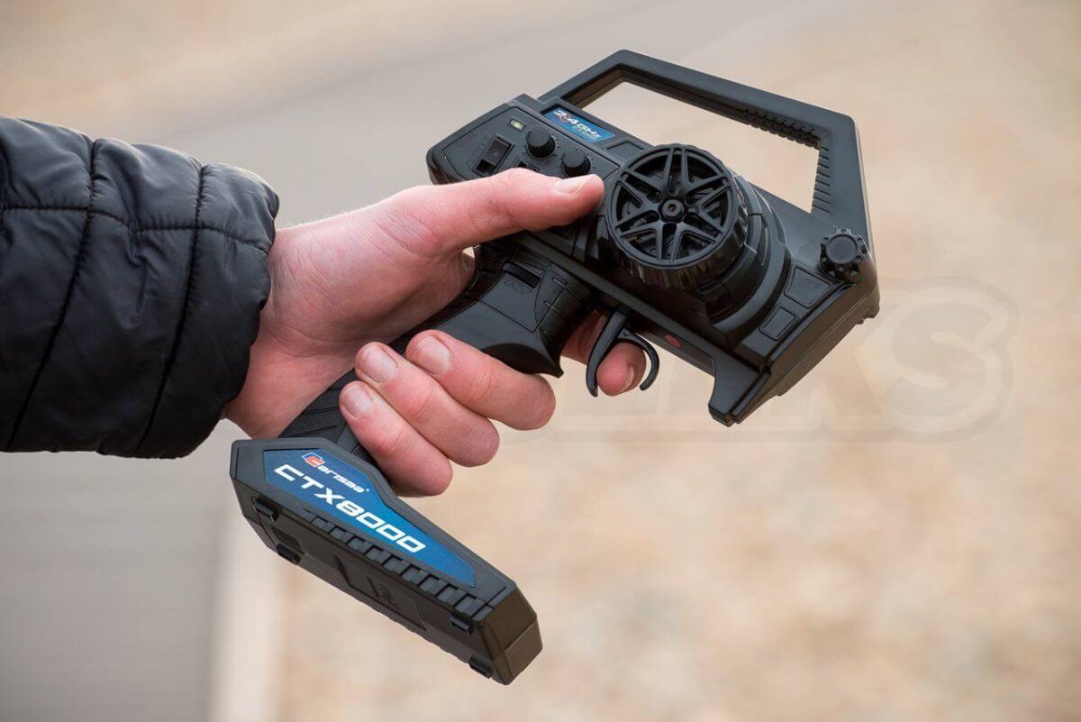

Modern **digital radio systems** employ direct sequence or automatic frequency hopping technologies to distribute their transmissions over a wider selection of frequencies (or in the case of frequency hopping, completely different channels) in the 2.4Ghz spectrum. These systems are **incredibly robust**, **resistant to interference** and provide **impressive range**despite their compact external antennas.

**Binding a transmitter**

The majority of transmitters that arrive bundled with models come **pre-bound** (already connected) to their respective receivers, but we need to replace components in the package, we will need to rebind them. For this we will need a charged battery in the model, the receiver accessible (remove the lid etc) and charged batteries in the transmitter.

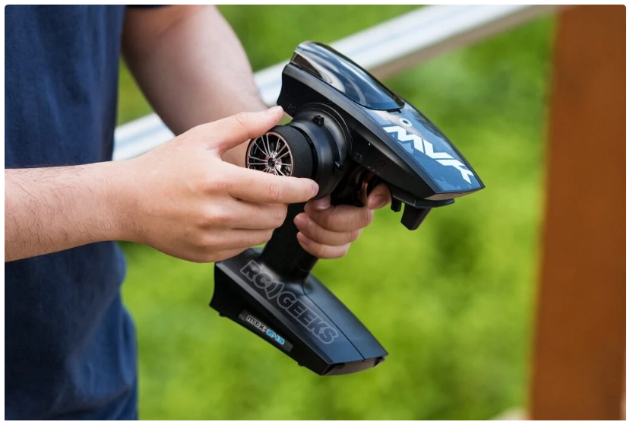

**Security Measures:** we will be using a fingerprint security model for delivering food supplies, medicines and goods. It will be used as an authentication method.

We will be using a MOXA-7 device for this purpose:

Mantra’s MOXA7 is a portable rugged biometric terminal utilized for diverse biometric enrolment and identification project needs. MOXA7 is equipped with a rugged fingerprint scanner and rear side 5MP camera to scan Barcode and QR code efficiently.

Barcode, QR Code Reader

Front & Rear Dual Camera

8000 mAH Battery Backup

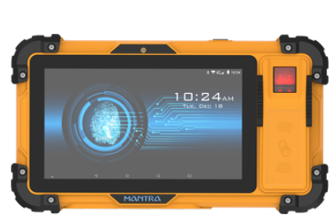

**Conclusion-**

It is essential in each situation to first establish that food supply is a correct response and then that the composition is defined and described after an adequate comprehensive survey. In every instance it is necessary to ensure that food donations are culturally and nutritionally appropriate for the affected population and that the costs of their purchase, transportation, storage and distribution is kept to a minimum. The balance between relief and more productive applications of food assistance, and the rate at which the balance can be shifted towards the latter, depends on many factors. These include the initial health and nutritional condition of the people, the possibilities for growing food or engaging in other income generating activities, government policies, security situation etc.

In the wake of a natural disaster a cascade of additional problems may emerge, one of the most critical being the lack of food. With local stocks ruined and supply chains either hampered or destroyed, it can be difficult for a person to simply find enough to eat after a disaster. Because of this threat, many public and private agencies provide post-disaster aid on both local and much larger scales. The United States’ Federal Emergency Management Agency, for instance, says they provided more than 63 million meals and snacks, and millions of gallons of drinkable water to the island of Puerto Rico in the aftermath of 2017’s Hurricane Maria. However, in the midst of that relief effort, questions began to emerge about what kinds of foods were appropriate after Puerto Rican residents found candy, chips and other snack food in relief packages. So what are the considerations that go into the foods that aid a disaster area? Some of the biggest are nutrition and logistics.

So in this report, an effective system is proposed to deliver food in disaster affected areas with minimum logistics and maximum security.

**Refereces-**

1. Carmen G. Rawls and Mark A. Turnquist,Pre-positioning and dynamic delivery planning for short-term response following a natural disaster, *Socio-Economic Planning Sciences,* Volume 46, Issue 1, March 2012, Pages 46-54
2. Burcu Balcik,Benita M. Beamon &Karen Smilowitz, Last Mile Distribution in Humanitarian Relief, *Journal of Intelligent Transportation Systems,* Volume 12, 2008 - Issue 2, Pages 51-63
3. D.Clay Whybark, Issues in managing disaster relief inventories, *International Journal of Production Economics*, Volume 108, Issues 1–2, July 2007, Pages 228-235
4. Philip R. Berke ,Ratana Chuenpagdee,Kungwan Juntarashote &Stephanie Chang, Human-ecological dimensions of disaster resiliency in Thailand: social capital and aid delivery, *Journal of Environmental Planning and Management*, Volume 51, 2008 - Issue 2, Pages 303-317